Look carefully at the solar eclipse below. Explain what you can see in the picture. Try and use scientific words. Start with the moon.

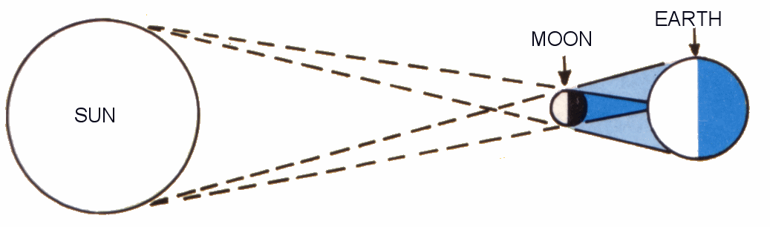

1. The moon which is orbiting the Earth moves between the sun and the Earth.

2. ________________________________________________________
________________________________________________________________________________________________________________________
____________________________________________________________

3. ________________________________________________________
____________________________________________________________________________________________________________________________________________________________________________________

4. ________________________________________________________
____________________________________________________________________________________________________________________________________________________________________________________
Remember: This is where you use your scientific knowledge. Don’t miss stuff out.

